[Year]

KAPINGA ASTRID TSHILUMBA

ST10478228

[Date]

The wede project

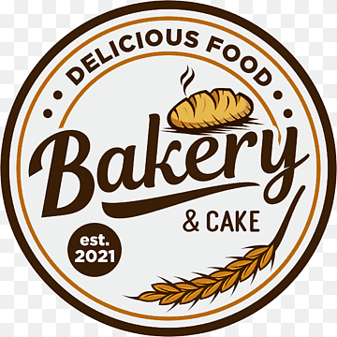

Table of Contents

Organization overview 2

2. Website goals and objectives 4

4. Website features 5

5.DESGIN AND USER EXPERIENCE 6

6. TECHNICAL REQUIREMENTS 6

7. Timelines and milestones 6

Budget 6

Reference 6

# Organization overview

Backstory

**Our Story**

Mommy’s Sou Chef was baked into life in September 2017, right in the heart of Cape Town. It all started with a daughter who missed the taste of her mom’s kitchen and dreamed of sharing it with the world. Blending a pinch of nostalgia with a dash of French flair, she created a bakery that brings Mom’s beloved recipes to life—one buttery bite at a time. Mommy’s Sou Chef isn’t just about pastries; it’s about memories, family, and the sweet joy of feeling right at home

THE VISSION

**Vision Statement**

To become the go-to bakery that bridges generations, creating a timeless space where tradition meets creativity, and every sweet bite tells a story of heritage and joy.

**Mission Statement**

Our mission is to bring local natives back to their cherished childhood memories through old ingredients and reinvented recipes, while introducing the youth to a taste of the past—allowing all ages, from children to elders with a sweet tooth, to experience a different time and place without leaving their community.

The target audience for this business is both the youth and the old natives. The people between the ages of 3+ until those people have a sweet tooth

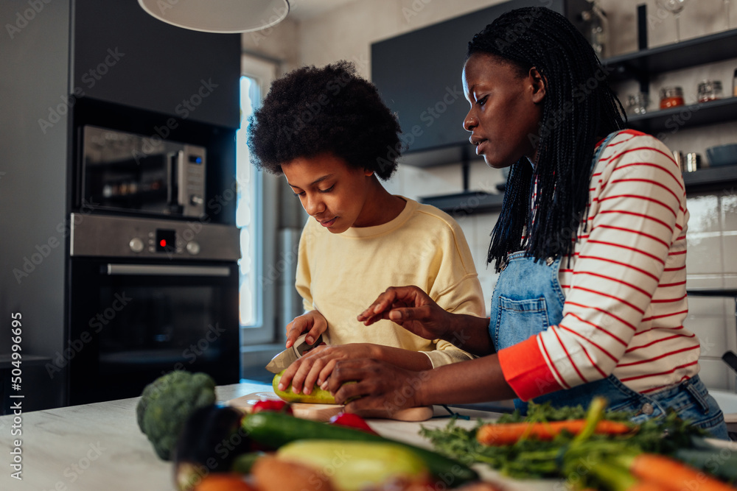

# 2. Website goals and objectives

THE GOAL

To spread awareness of the bakery among locals and expand to a wider online audience, driving both **digital engagement** and **in-store visits** through:

* Engaging posts
* Eye-catching imagery
* Thoughtful product pricing and presentation

To measure success, the following KPIs will be tracked:

1. **Website Engagement**

* Increase in average session duration where users spend more time exploring.
* Higher number of pages visited per session.
* Growth in social shares and comments.

1. **Online Sales**

* increase in online orders from the website.
* Increase in repeat online customers.
* Growth of followers/subscribers on bakery’s digital channels.

1. **In-Store Impact**

* Growth in walk-in customers mentioning website promotions/posts.
* Improved sales volume linked to online campaigns.
* Increase in loyalty card signups or customer return rates.

# 4. Website features

Website features

**We have 3 main pages**:

* Home
* About
* Contact
* menu

# 5.DESGIN AND USER EXPERIENCE

Website design

**Color Palette**

Use soft, dessert-like pastels to give a warm, playful, and welcoming feel:

* **Baby Pink:** for headers, buttons, and highlights.
* **Light Yellow:** for background sections or call-out boxes.

**Typography**

Use big, round, friendly fonts that look inviting

Layout and Design

# 6. TECHNICAL REQUIREMENTS

HTML, CSS, and JavaScript

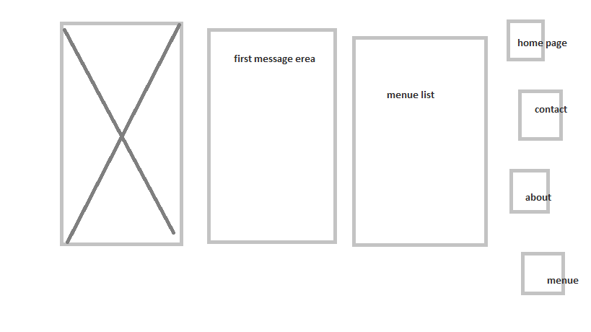

**The menu page**

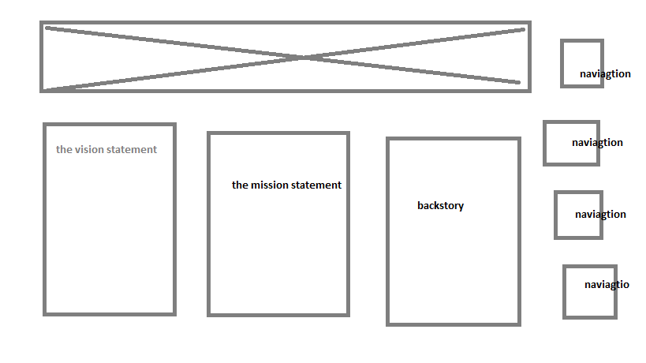

**The about page**

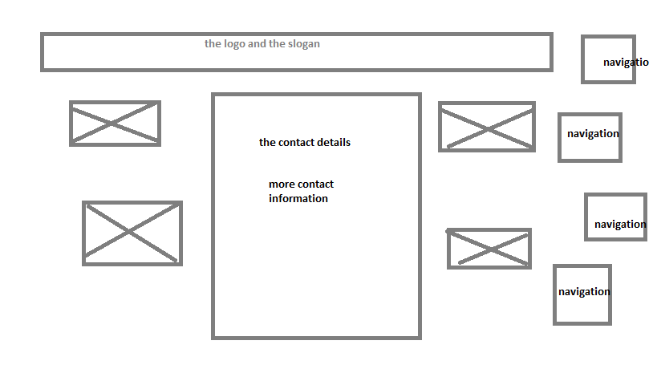

**The contact page**

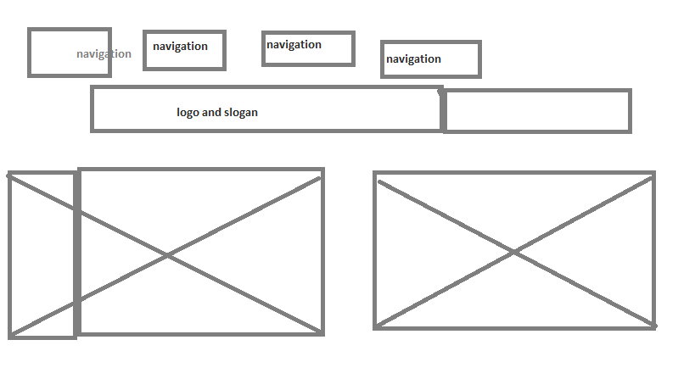

**The home page**

# 7. Timelines and milestones

**Week 1 — Establish a baseline.**

* Launch updated website/social pages with consistent pastel branding.
* Record **current engagement metrics**:
  + Website visitors per day/week
  + Social media followers and average post likes/comments
  + Average walk-in customer count per day
* Goal: Have all tracking systems (Google Analytics, Facebook/Instagram Insights) working.

**Week 2 — First engagement push**

* Post 3 high-quality product images with captions telling your story.
* Run a simple poll or Q&A to get audience responses.
* **Target milestone:** 10% increase in average social post interactions (likes, shares, comments) compared to baseline.

**Week 3 — Interaction growth**

* Reply to every comment and DM to show active engagement.
* Share behind-the-scenes content (baking process, family story).
* **Target milestone:** Website session time up by 10% and at least **1–2 customer inquiries/orders coming from social posts.**

**Week 4 — Stronger calls-to-action**

* Post “limited offer” or “special pastry of the week” to encourage foot traffic.
* Encourage customers to tag your bakery on Instagram or Facebook.
* **Target milestone:** 15% more social mentions/tags and at least **5 customers citing a post as the reason they visited.**

# Budget

| **Item** | **Description** | **Cost (ZAR)** | **Fun Name / Notes** |
| --- | --- | --- | --- |
| **Sweet Spot Domain** | Your bakery’s web address (. co.za or .com) | R250 | “The Door to Our Online Kitchen” |
| **Pastel Palette Design** | Website theme & layout | R3 500 | “Making the Website as Sweet as Our Pastries” |
| **Logo & Branding** | Bakery logo & brand visuals | R1 200 | “The Face of Mommy’s Sou Chef” |
| **Delicious Photos** | Professional product photography | R4 500 | “Picture-Perfect Pastries” |
| **Copy & Storytelling** | ‘About Us’, product descriptions | R2 000 | “Telling Our Sweet Story” |
| **E-Commerce Setup** | Online shop installation & payment gateway | R3 000 | “Opening the Online Shop Window” |
| **Initial SEO Setup** | Optimizing Google & search | R1 800 | “Helping Sweet Searches Find Us” |

|  |  |  |  |
| --- | --- | --- | --- |
|  |  |  |  |

# Reference

Montgomery, K. (2021) *Step by step guide to creating a bakery costs spreadsheet*. Bake This Happen. Available at: <https://www.bakethishappen.com/blog/bakery-costs-spreadsheet> (Accessed: 27 August 2025).

Sudra, A. (2025) *How Much Does It Cost to Build a Bakery Website*. Deonde, 22 August. Available at: <https://deonde.co/blog/cost-to-build-a-bakery-website/> (Accessed: 27 August 2025

Timofeeva, E (2024) Bakery Website Ideas, Tips, and Secret Ingredients,16 October

Available at: <http://sendpulse.com/blog/bakery-websites>

Charly’s Bakery (no date) *Mucking Amazing Cakes*. Charly’s Bakery. Available at: https://www.bakethishappen.com/blog (Accessed: 27 August 2025).

Mommy’s Sou Chef (2025) Product photography of cakes and pastries. [Photograph]. Cape Town.

Tshilumba, A. (2025) Wireframe of home page. [Image created in Paint]. Cape Town

Tshilumba, A. (2025) Wireframe of contact page. [Image created in Paint]. Cape Town

Tshilumba, A. (2025) Wireframe of menu page. [Image created in Paint]. Cape Town

Tshilumba, A. (2025) Wireframe of about page. [Image created in Paint]. Cape Town

Tshilumba, A. (2025) sitemap visual page. [photograph]. Cape Town

<https://recipevibe.com/storage/2025/04/chocolate_chip_cookies_recipe_1RVUoGWqGXS1Z5GK8-K0uK9ojK0CM_3b0.jpg>